# **Name: Abdurrahman Qureshi**

# **Roll No: 242466**

Practical No: 9

Date Of Performance: 26/09/2025

Aim: Learn Docker File Instructions, build an image for a sample application using Docker File.

fizzbuzz.js

console.log("FizzBuzz Docker Container Starting...\n");

for (let i = 1; i <= 100; i++) {

    if (i % 3 === 0 && i % 5 === 0) {

        console.log(i + " ==> FizzBuzz (divisible by 3 and 5)");

    }

    else if (i % 3 === 0) {

        console.log(i + " ==> Fizz (divisible by 3)");

    }

    else if (i % 5 === 0) {

        console.log(i + " ==> Buzz (divisible by 5)");

    }

    else {

        console.log(i + " ==> Regular number");

    }

}

console.log("\nFizzBuzz completed!");

package.json

{

    "name": "fizzbuzz-docker",

    "version": "1.0.0",

    "description": "FizzBuzz application in Docker",

    "main": "fizzbuzz.js",

    "scripts": {

        "start": "node fizzbuzz.js"

    },

    "keywords": [

        "fizzbuzz",

        "docker",

        "javascript"

    ],

    "author": "qarq90",

    "license": "MIT"

}

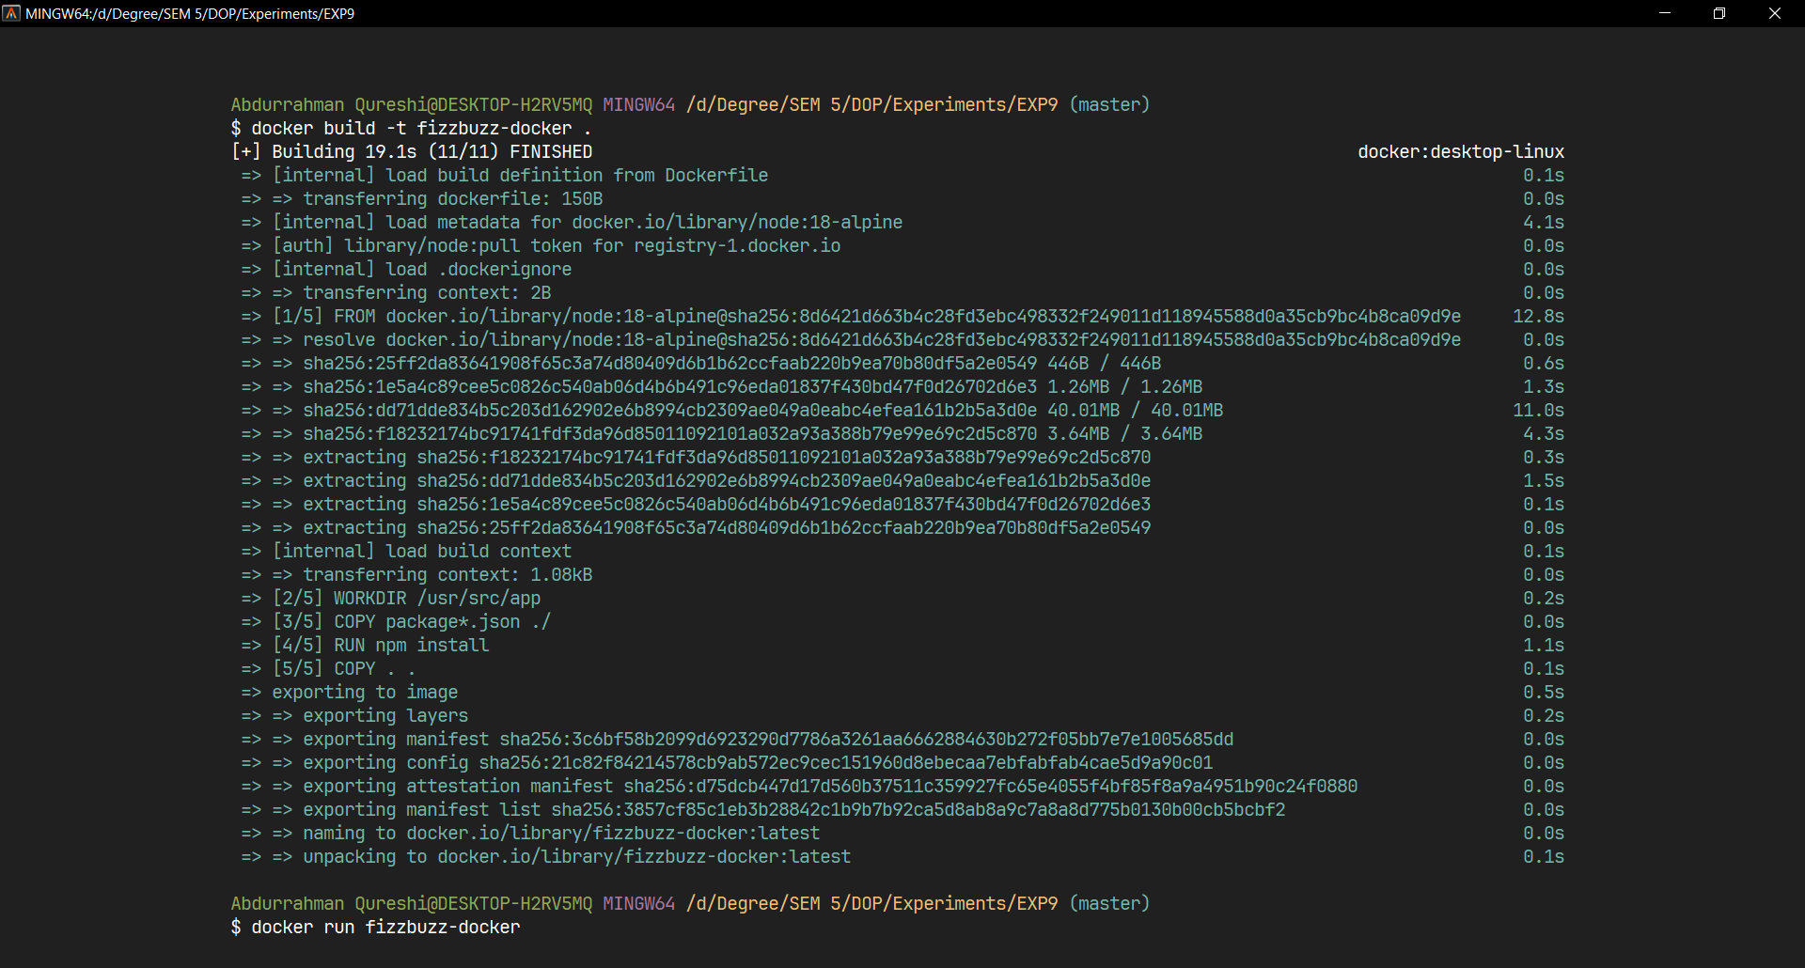

Building the docker image

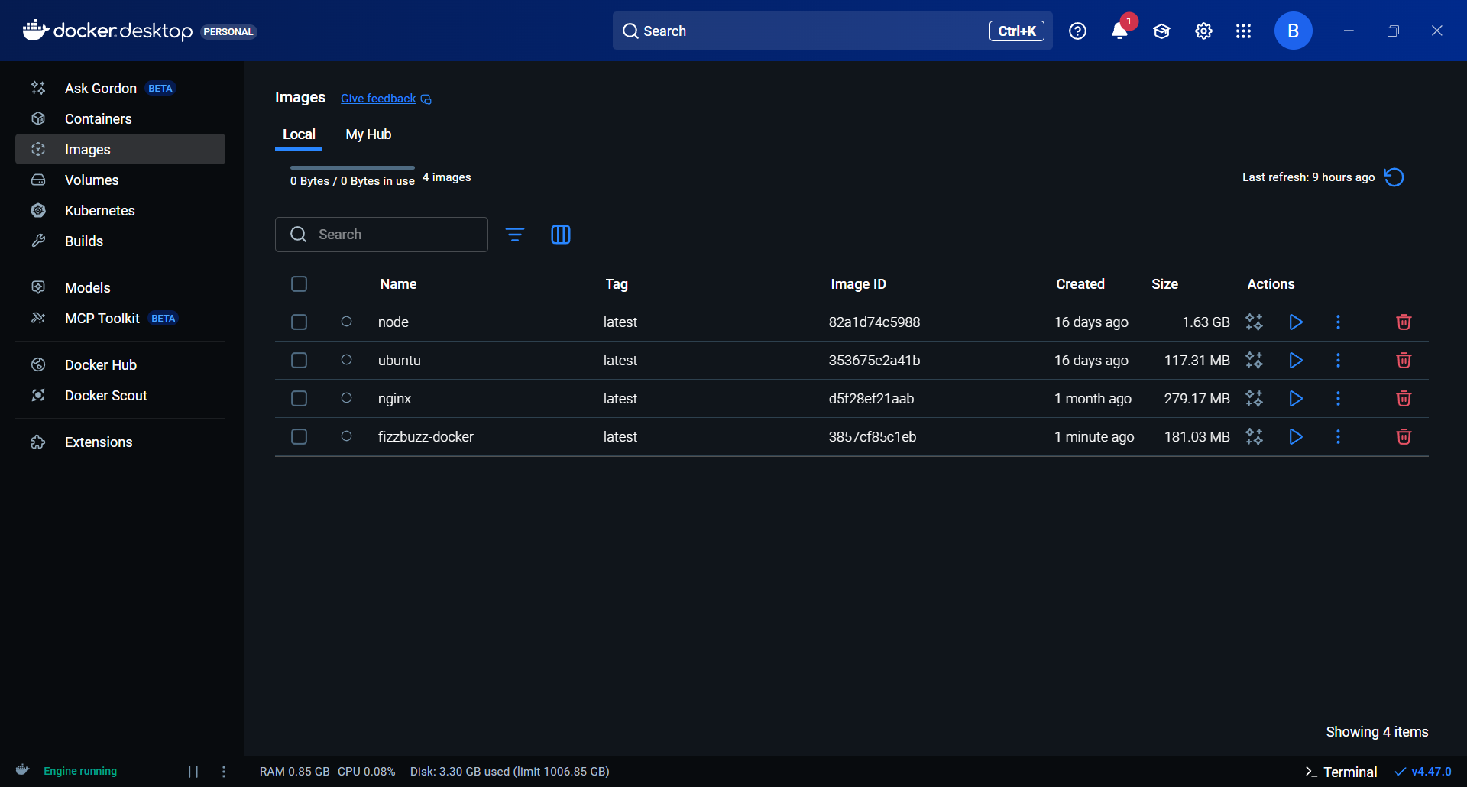

Image ‘fizzbuzz-docker’created in docker desktop

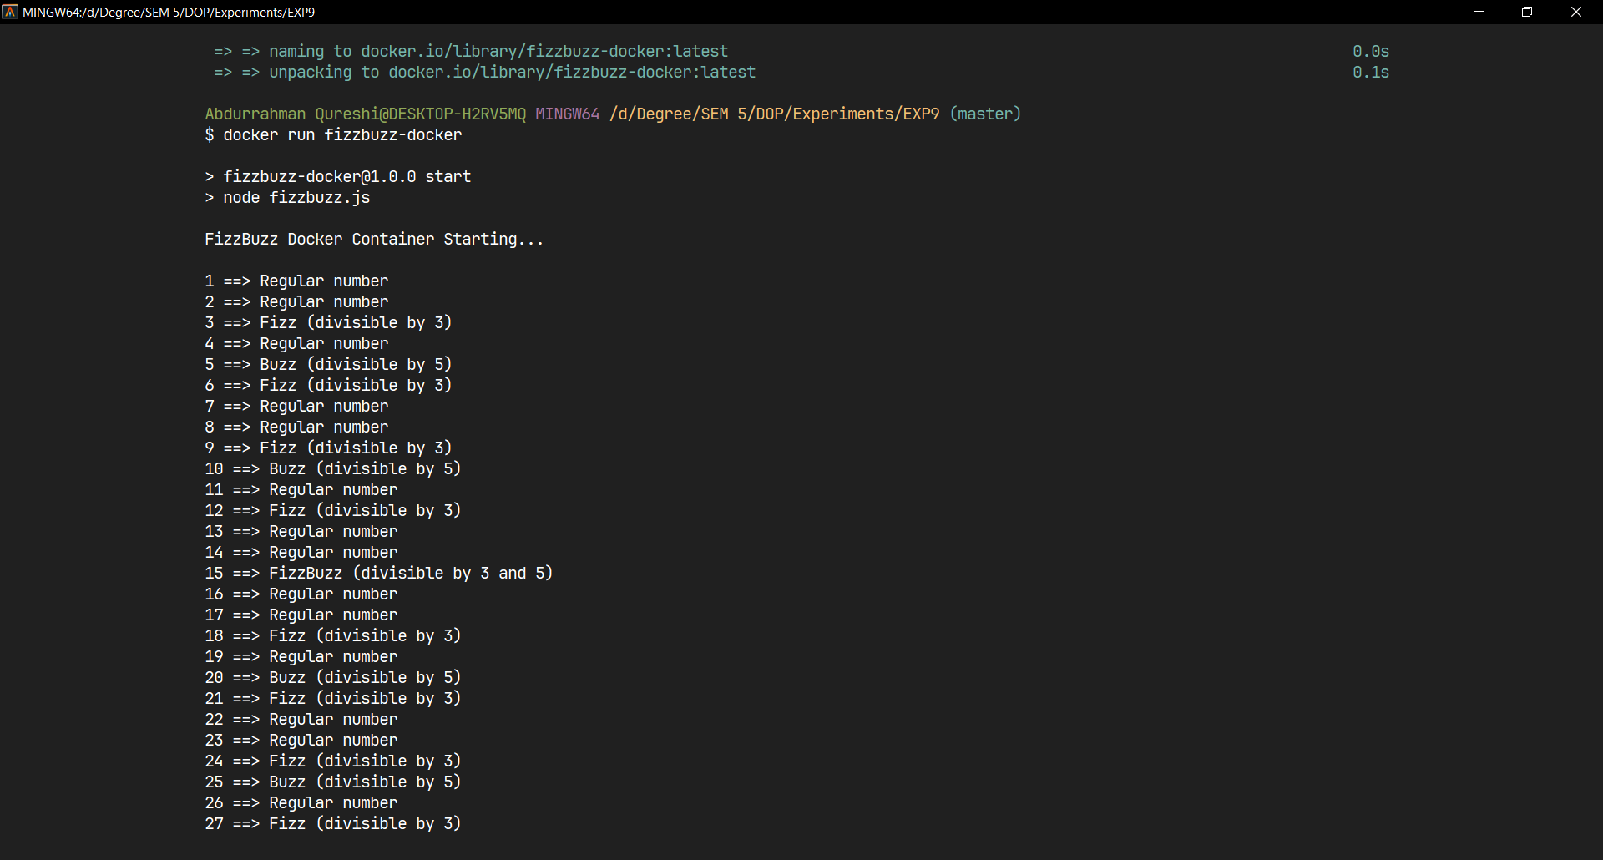

Executing the image locally on terminal

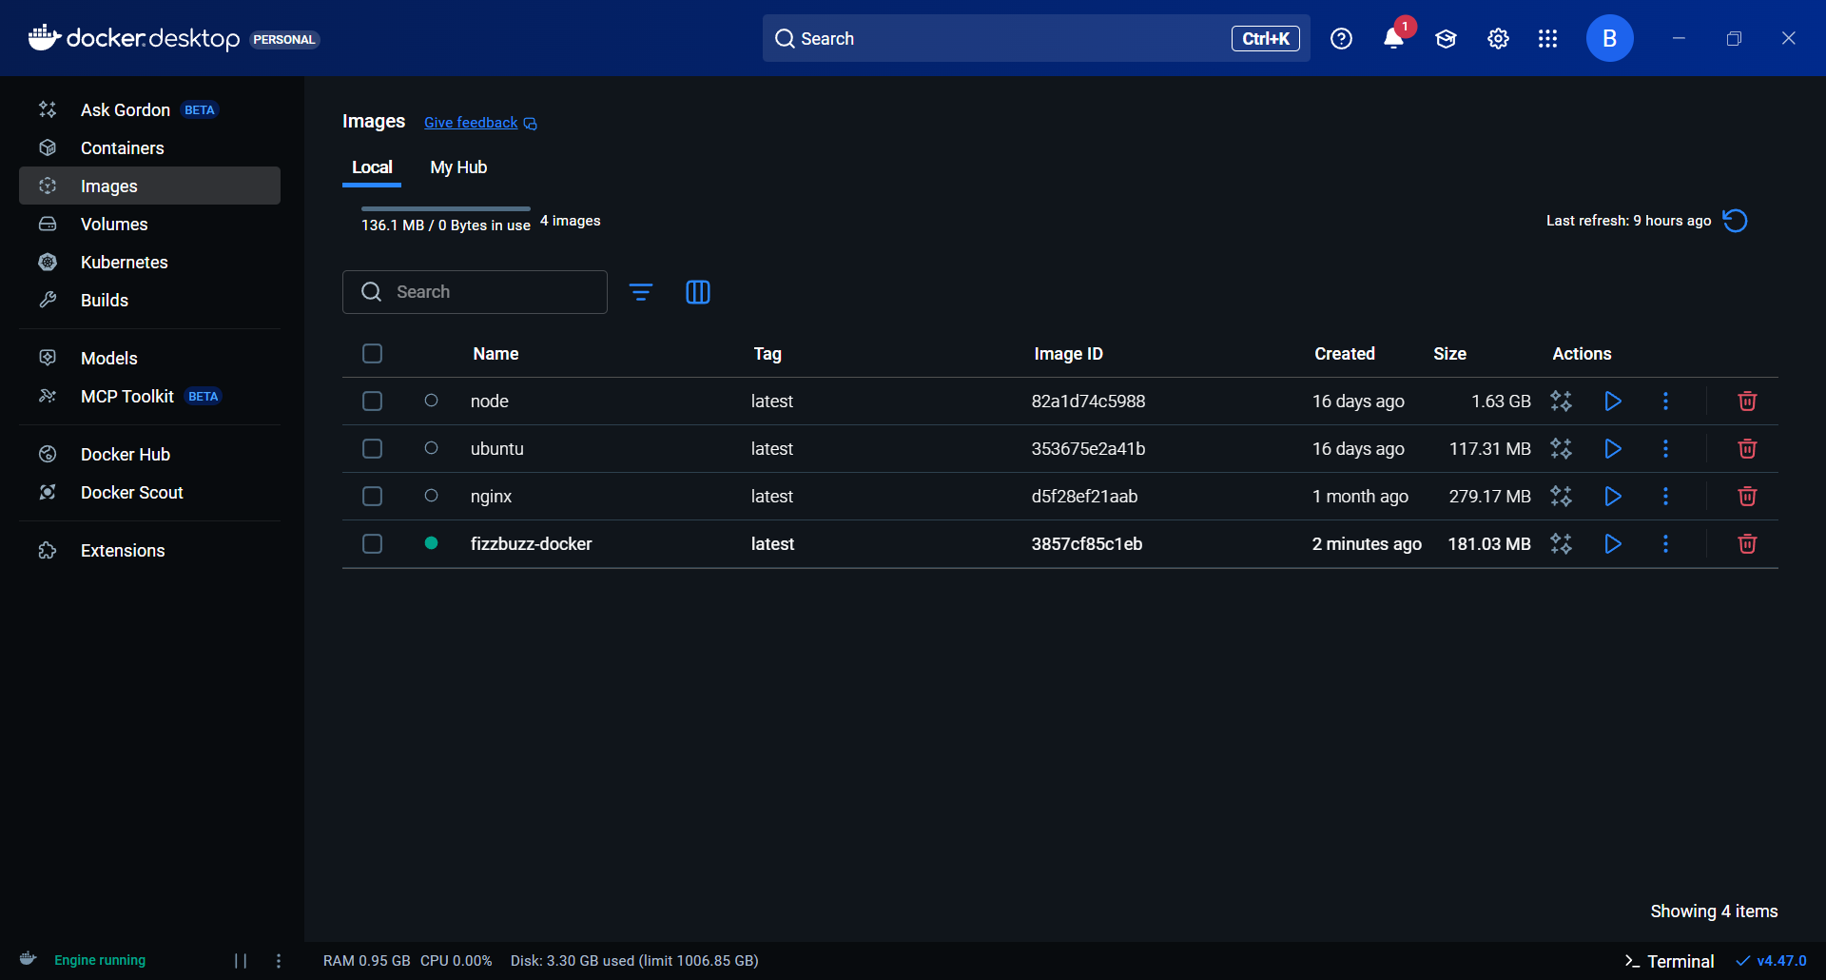

Image status running shown in docker desktop

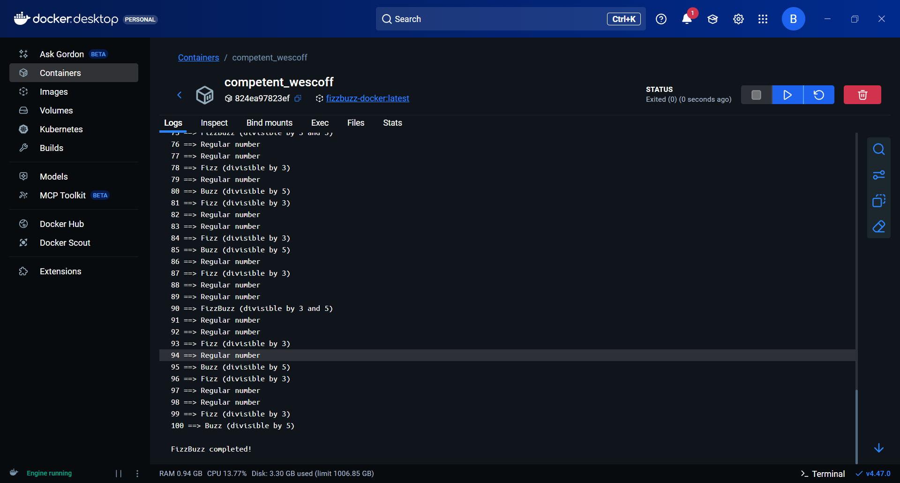

Executing the image from docker desktop

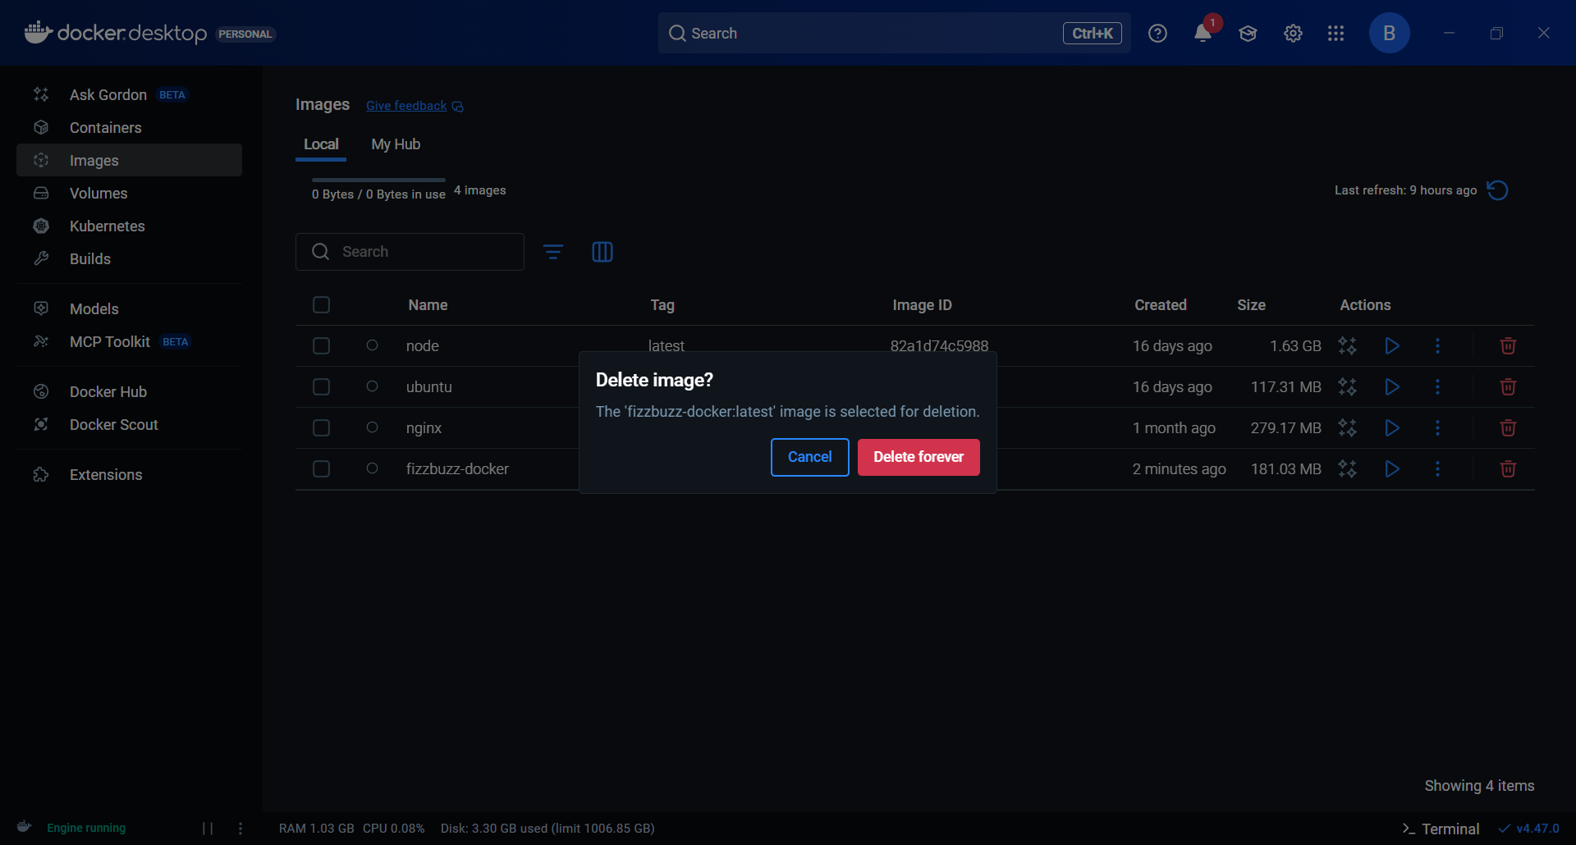

Deleting the image and container